**Project Assignment for ENM 308 and BIM 213**

Consider the product structure that belongs to a snow shovel. The demand and the inventory data provided below:

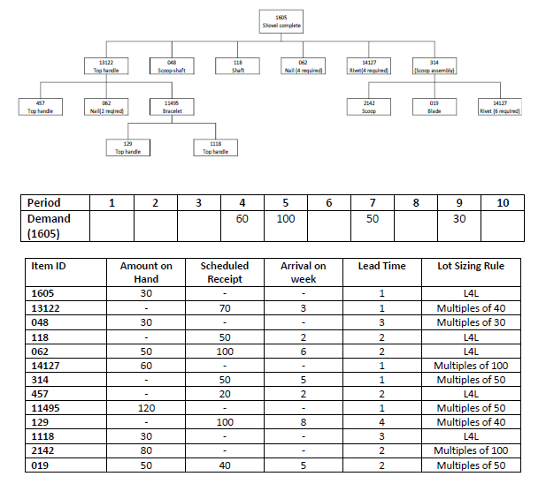

Develop a computer program that takes bill of material and the gross requirements of the end item along with the stock, scheduled receipt, arrival on week, lead time and lot sizing rule information of the subcomponents to create MRP records for all parts and components of the snow shovel. You are free to use any programming language with your peers from Computer Engineering department. However, the generated outputs of the designed code must exactly match the MRP record standards. Your code should be able to handle parent/child relationships, low level coding and interactions between parent and child components in terms of generating gross requirements for all subcomponents.

**Important Notes**

* Progress report must include the following contex.
  + A brief explanation of MRP.
  + Solve the given problem by hand and create MRP outputs.
  + Flow chart of your program.
  + Pseudo code of your program.
* Final report must include the following contex.
  + What are the differences between the planned program in the first report and final report?
  + MRP outputs of the program.
  + Which data structures are utilized? Why?
  + Submit source code of your program as zip or rar file.
* In program implementation :
  + Determine which data required to be taken from the user and which data should be constant
  + Make a txt file and store constant data
  + Read the txt file on run
* Your program have to :
  + be accurate on computation (correctness)
  + have a user-friendly interface
  + deal with software bugs
  + handle unreasonable conditions (what if it's not possible to complete order on time)
  + utilize proper data structures and algorithms